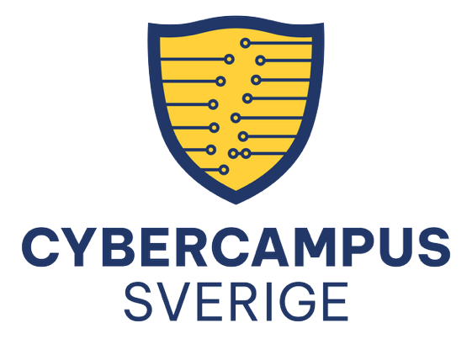

Cybercampus Sweden is a national initiative and a collaboration between universities, institutes, authorities and companies throughout Sweden. Cybercampus unites expertise across Sweden in an interdisciplinary effort to fill gaps that no single actor can fill – for increased cybersecurity, strengthened society’s defence capability and Sweden’s competitiveness.

Share events
As a Cybercampus partner, you are welcome to share cybersecurity-related events in the calendar on Cybercampus.se. This will increase the visibility of your events while also helping to keep the Cybercampus website up-to-date and ensuring that more people gain access to information about relevant activities.
This file includes a template and examples of how events are presented in both the calendar overview and on individual event pages.

Follow these steps:
1. Complete the template on the next page.
2. Email the file, or paste the information into the message, to events@cybercampus.se. Please write “Calendar” in the subject line.
3. Cybercampus’ webmaster publishes the calendar event.

Calendar Event on Cybercampus.se
Email the information to: events@cybercampus.se
Subject: Calendar
Title*
Host*
Place (online or address) *
If the event is online, add a link if available.
Day and time (from and to)*
Target groups*
Language*
Use the event’s main language in the calendar entry. However, the title and description can be in more than one language.
Short description *
Long description
Registration link
Contact person
Is the event on LinkedIn?
If yes, attach the link.
Image?
Attach an image in JPG or PNG format in the email.

* This information is mandatory.

Examples of calendar events on Cybercampus.se
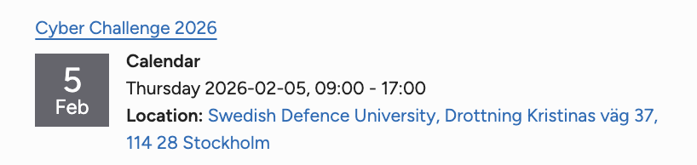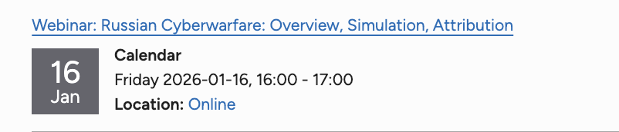
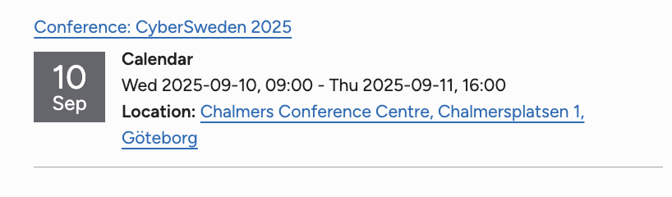

Example of calendar event page

